**Solid Principles and Design Patterns**

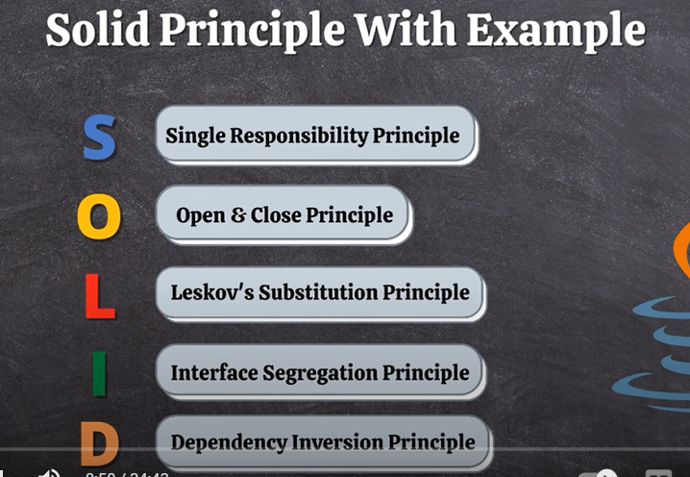

[**https://medium.com/@javatechie/solid-design-principle-java-ae96a48db97**](https://medium.com/@javatechie/solid-design-principle-java-ae96a48db97)

**Singleton Design Pattern**

[**https://www.programiz.com/java-programming/singleton#:~:text=In%20Java%2C%20Singleton%20is%20a,creation%20outside%20of%20the%20class**](https://www.programiz.com/java-programming/singleton#:~:text=In%20Java%2C%20Singleton%20is%20a,creation%20outside%20of%20the%20class)**.**

**How to Break Singleton Design pattern in Java**

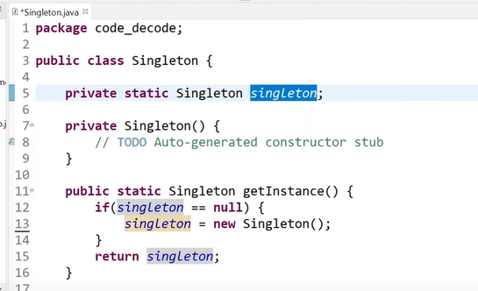

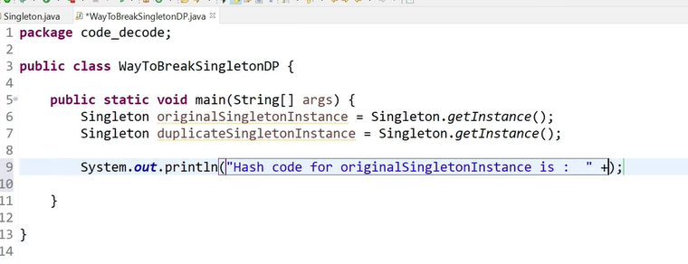

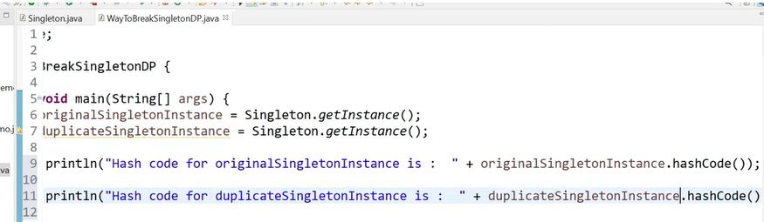

With the help of Reflection you can break singleton design pattern.

Why should we use design pattern?

Design pattern makes your code manageable and more scalable, testable and its break in module. Design pattern speed up the development process.

Creational Design Pattern:

Creational design pattern are those patterns which focus on the creation of the project.

Structural Design Pattern:

Structural design patterns are those pattern which are concerned about the composition of class and entity. So that eventually it contributes to building a large structure.

Behavioral Design pattern:

Behavioral pattern concentrates on the interaction of the object and their responsibilities. It says that object should be easily able to talk to each other but at the same time they should be loosely coupled.

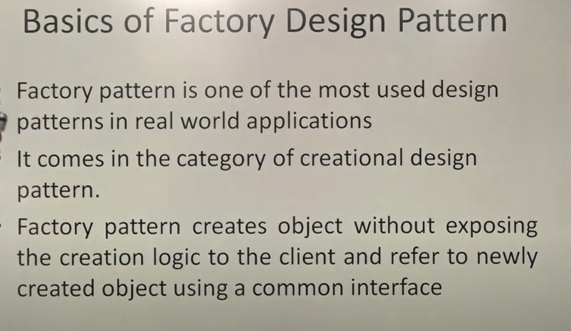

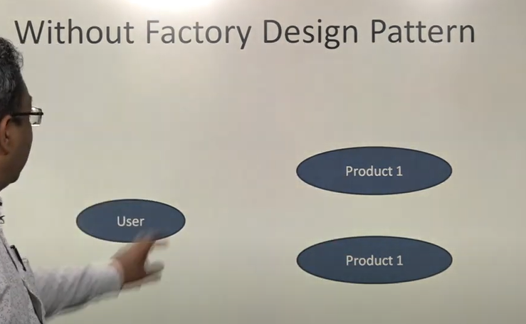

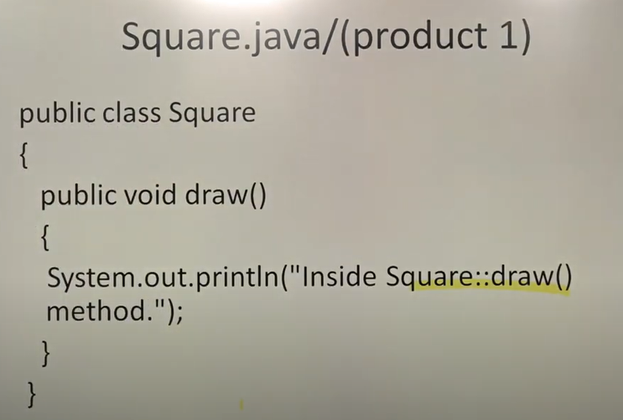

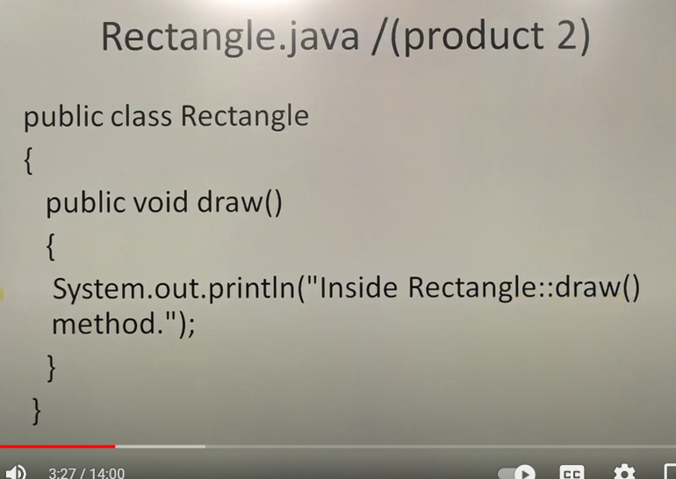

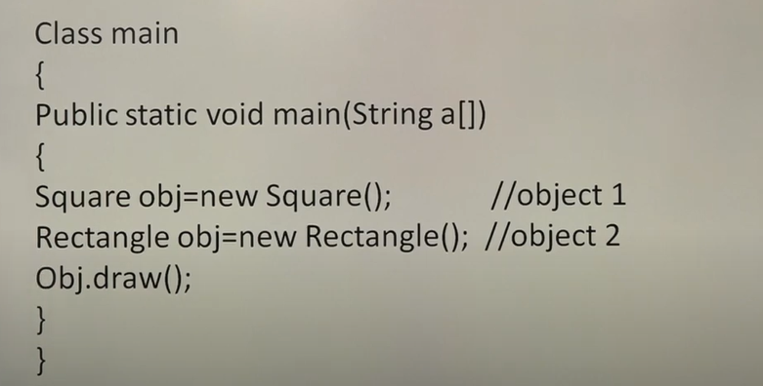

With different concept

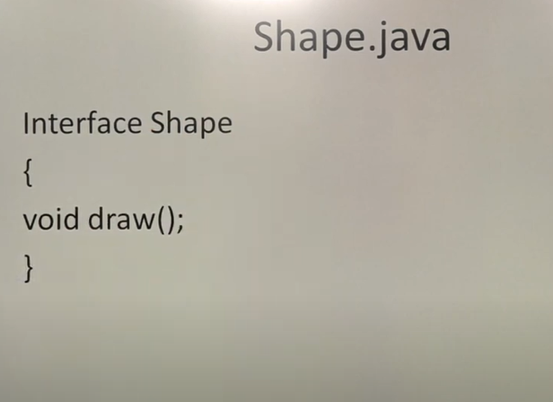

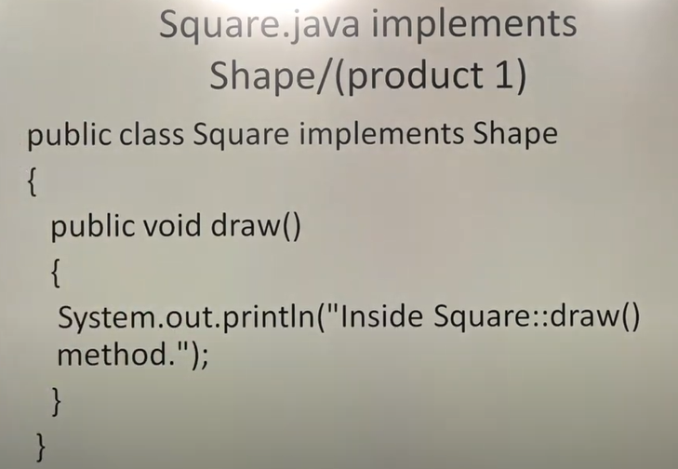

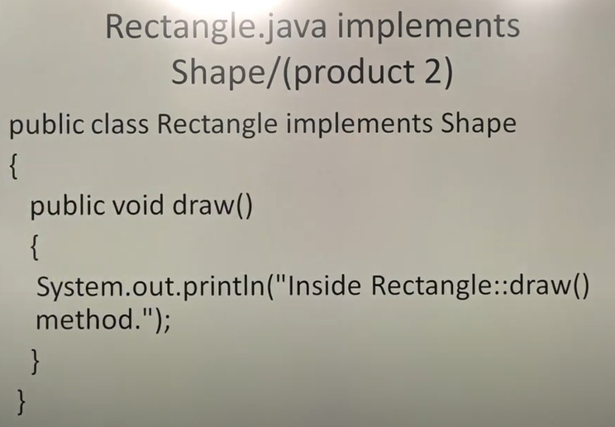

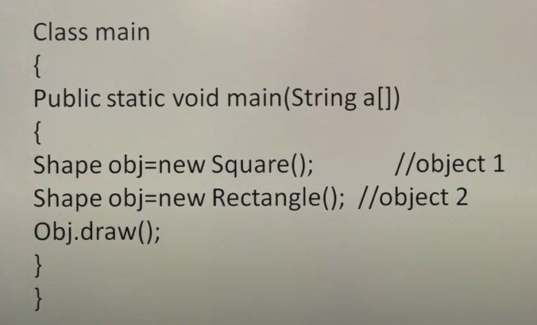

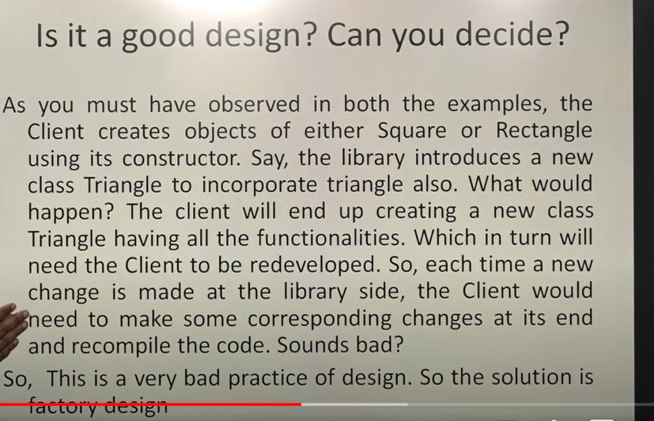

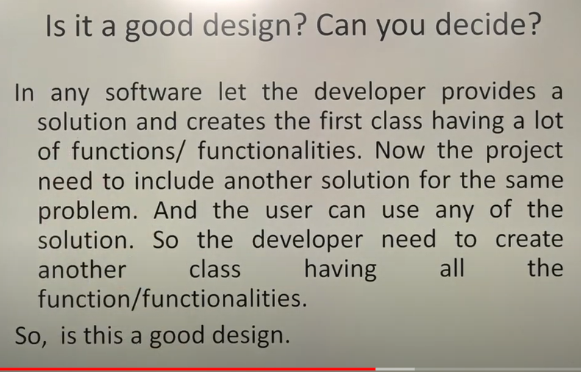

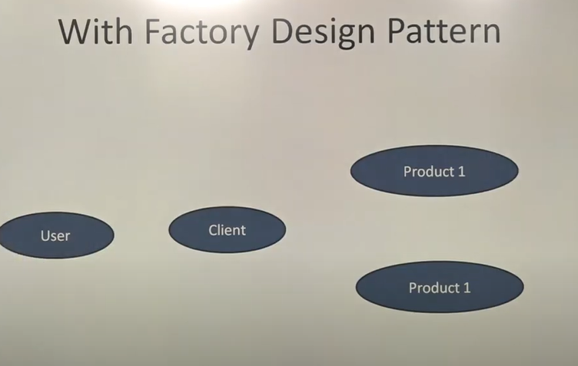

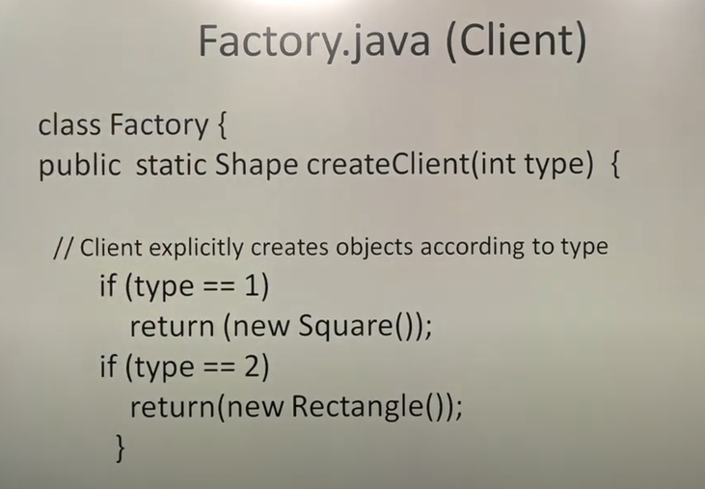

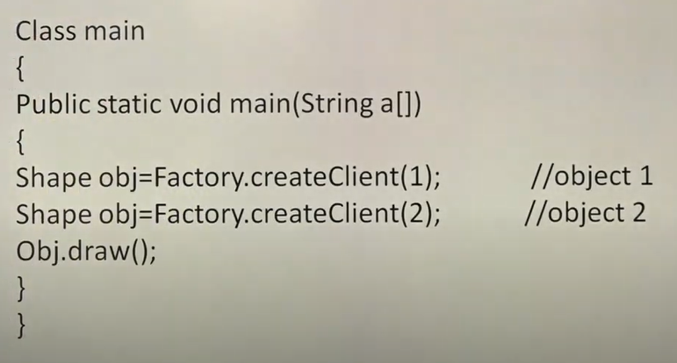

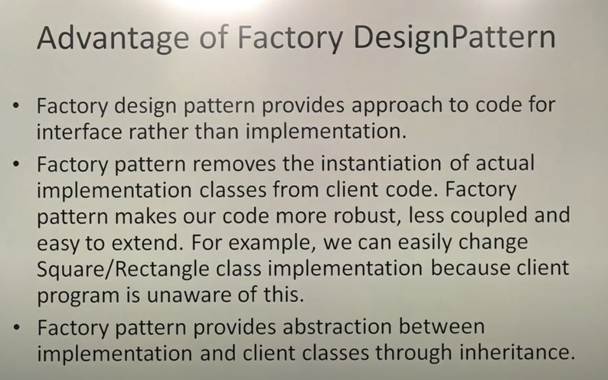

# Builder Design Pattern

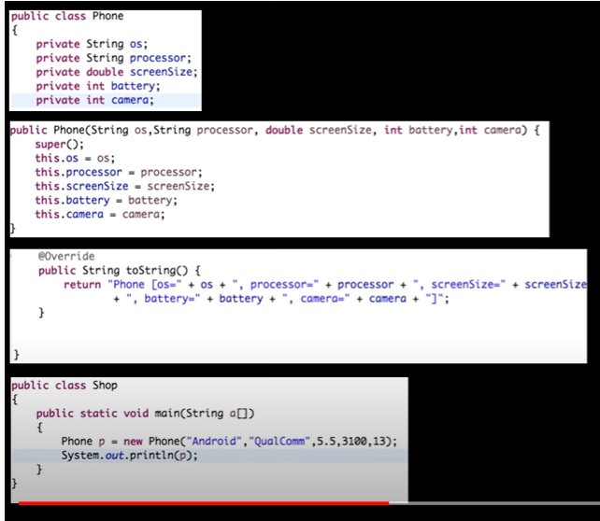

If you want to set values tw aap ko saari order mai set karni hongi

Builder pattern use karne sai hum order ko nahi dekhengay or apni marzi sai kuch values ko set karwayengay.

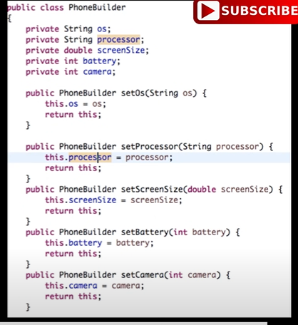

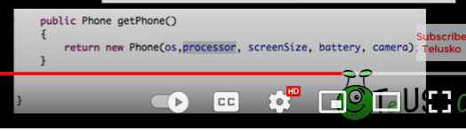

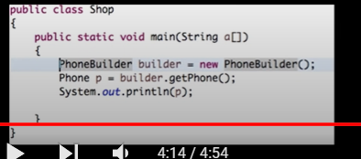

Why do we use builder pattern in java?

The builder pattern **simplifies the creation of objects**. It also simplifies the code as your do not have to call a complex constructor or call several setter methods on the created object. The builder pattern can be used to create an immutable class.

What is the real life use case of the Builder design pattern?

The simplest real world example of the builder pattern, which most of us are familiar with, is **when we make (or order) a pizza**. The pizza toppings cannot be added in any random order or the whole thing is likely to come out a mess. Instead, there is a step-by-step process that is followed.

When should a builder design pattern be used?

The builder pattern, as the name implies, is an alternative way to construct complex objects. This pattern should be used **when we want to build different immutable objects using the same object building process**

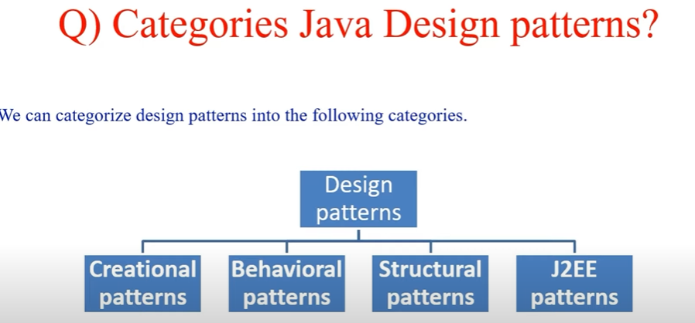

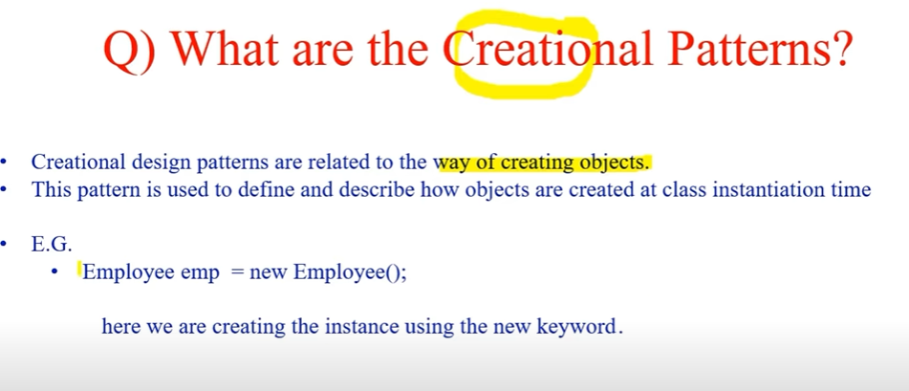

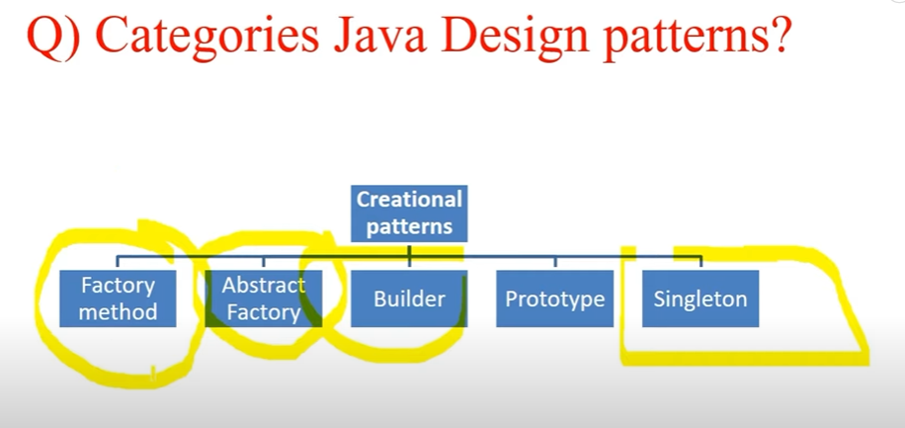

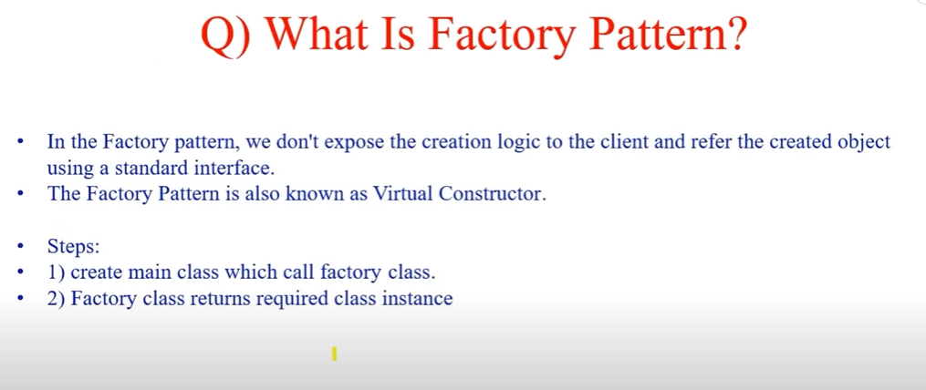

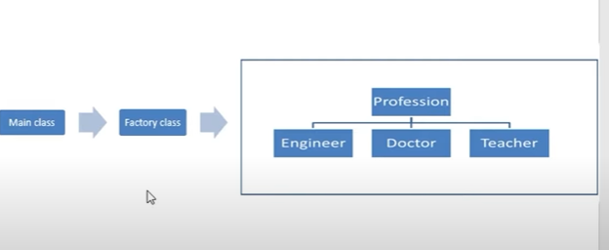

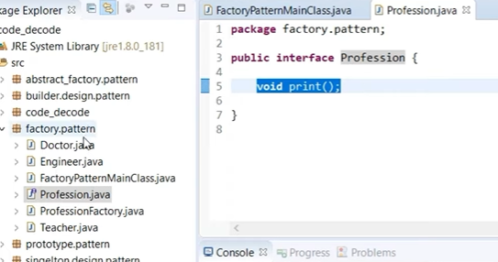

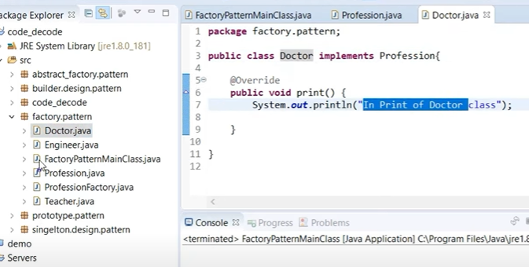

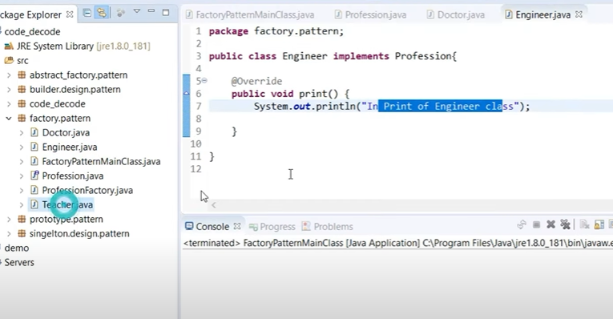

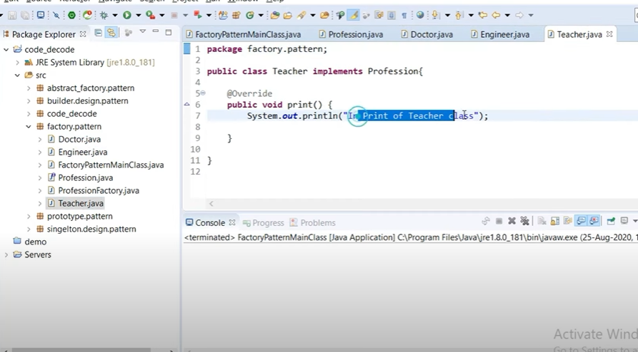

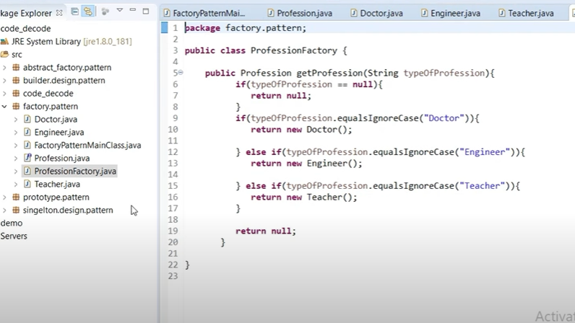

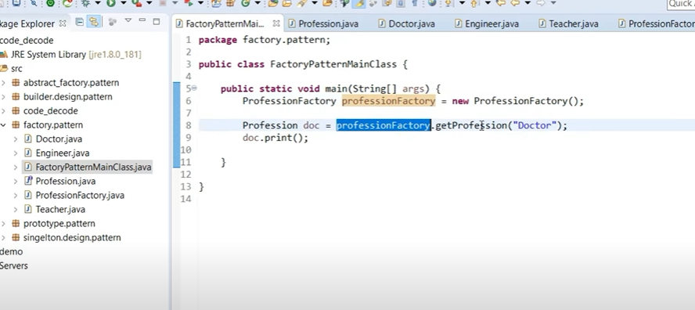’

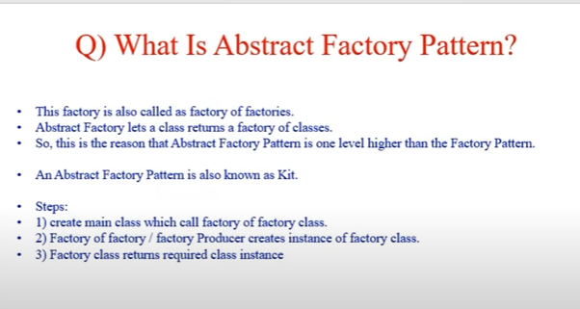

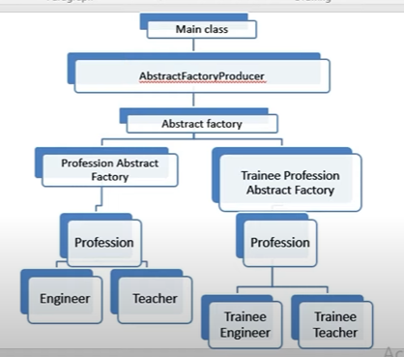

<https://github.com/codedecode25/design-patterns/tree/master/src>

# Prototype Design Pattern

